Context
Health and social care is a complex system – change comes about when:
- The need for change is clearly defined and people are given the opportunity to ‘get their head around it’ – staff, service users and communities.
- People are actively engaged in designing a better service – framing and reframing the issues, connecting with people on both an emotional and intellectual level - tapping in to people’s core needs and values - what is important to them. Developing insights to inform the change.
- Change is delivered across multiple processes and there are many phases of engagement – some changes are sustained, others are not and the process of engagement begins again. Patience and resilience are required.

Creating the conditions for change will help you address complex challenges through the lens of systems change. Change is not linear and dealing with emergent and constant change requires flexibility and adaptability at all stages. Also remember staff have to manage service continuity while at the same time deliver ‘change’ – change is constant and we need to see it as an inherent part of our roles – something we deal with every day.

Purpose  This Template combines all the elements of the People and Culture Change Platform as a complementary offering to Creating Conditions for Change and Innovation: How to get ready for change booklet. It provides 20 prompts to assist your early thinking when you are planning change – the prompts can also be reviewed at regular intervals. You may need to revisit key elements of your plan to support you along the way and to sustain the changes.  Who might use it?  We all have a responsibility for change – change is an inherent part of our roles. This Template is particularly relevant for those leading out on a specific change programme / initiative at any level in the system. Also remember we cannot deliver change on our own – so think about who you need to engage with at an early stage to help develop insights and support the change.  How to use it?  - Use this Template to support individual or team reflection.  - Think about how best to create a reflective / learning culture – a safe place to share insights, concerns and hopes based on your collective experiences.  - Agree how you will share the learning and put an action plan in place.  Note: This Template is aligned to the Health Services Change Guide and to Creating Conditions for Change and Integration click here to access. | 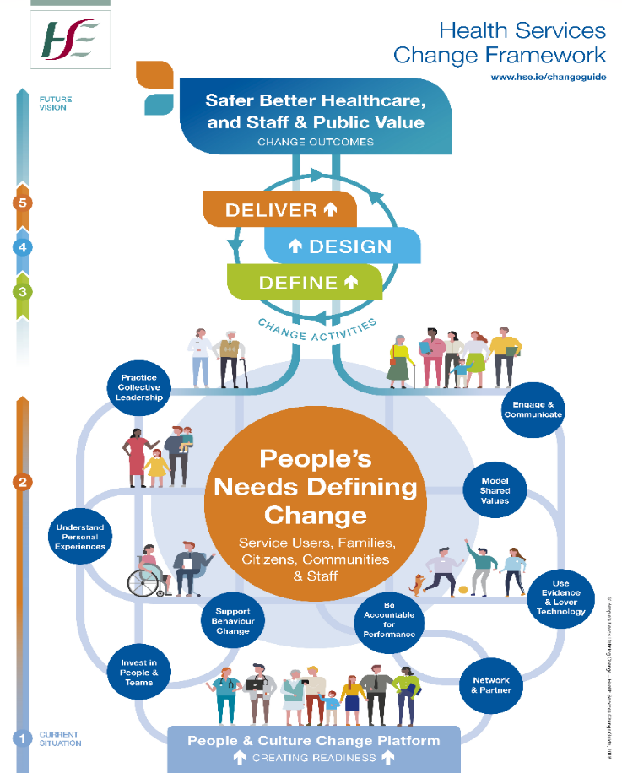
Creating Conditions for Change
Name of individual / service / team: Date:
Checklist | Top Tips and Additional Prompts | Identify Actions
- Collective Leadership & Values
- Secure sponsorship from senior leader/s to provide the mandate and resources for the change. How will they incentivise the changes? | Think carefully about who you need to engage with to lever support:  - Key influencers and decision makers – people who will influence change at different levels in the system.  - How visible are they? How engaged are they?  - How will they demonstrate their support?  CG pgs 68-70
- Connect and align your change efforts. | Alignment is key – where this change fits in the bigger context?  - Do people understand the need for change – the WHY?  - How does it fit with your service and organisations priorities?  Template 6.2.2: Context for Change – Why What How Method
- Keep focused on a shared purpose – a noble goal – that adds value for the people you serve. | Keep re-framing the messages to build commitment towards a compelling purpose.  - What will help people find meaning and purpose?  - Remember what motivates and inspires you might be different for others.  CG pg 52 (Fig 34)
- Develop relationships and share responsibility with others to build a coalition for change. | Think about what collective leadership means for you. Remember change is more about relationships and connections with people.  - Create opportunities for leaders to interact with each other – they will quite naturally find ways to connect their activities and find solutions that work.  CG pgs 11-13
- Be mindful of your core values and the behaviours you role model. | Build trust through relationships before you try to influence. Challenge your own biases, question norms and be open to new ideas.  CG pgs 14-16
- Engagement & Networking
- Build a coalition of people that will support the change – a small, but large enough, group of people who can exert influence and who can support you. | You cannot deliver change on your own – you need to invest time in building these relationships and networks.  - Be open to working with people with different views and perspectives.  - Always engage with the people who will have to implement the changes.  CG pgs 17-19; 38-49
- Include service users and frontline staff from the outset – value their insights and experiences. | Don’t wait to have your ‘house in order’ – remember service users and staff will bring an honest perspective based on their experiences. You need their insights to help you design the change.  - This requires courage and agility to keep the focus and still adapt to new thinking and suggestions.  CG pgs 44-45
- Engage and communicate early and often with a clear purpose. | Visit people on site to see what it is really like for them and learn from their experiences. Visit new locations / places.  - Who will implement and have you engaged with them?  - How will the change impact on these individuals or teams?  Review your communication and engagement – include the voice of the service user and frontline staff. Be creative in your approach.  CG pgs 17-19 | Template 6.1.2: Guidance on Stakeholder Mapping and Analysis  Template 6.1.3: Guidance to Develop Engagement and Communication Plan
- Pay particular attention to meeting peoples’ ‘basic needs’ – resources to do their job, safe work environment, staff health and wellbeing. | Engagement is directly linked to people’s sense of being treated fairly and with respect.  - Don’t underestimate the power of getting the basics right as a key enabler of change.  CG pg 18 (Fig 11a)
- Encourage widespread multi-stakeholder engagement and action focused on a shared purpose. | Actively develop partnerships and networks.  - Recognise the collective capacity and responsibility to solve challenges together.  - Create forums that allow this engagement and creativity.  CG pgs 27-29
- Personal Experiences & Behaviour Change
- Support personal learning and prioritise investment in teams. | No one becomes an expert in a new skill overnight so provide opportunities for people to practice new skills / work practices in safe environments to build confidence.  - Remember most change is delivered through teams – keep the focus on supporting teams to deliver change together.  CG pgs 25- 26; 92-93
- Take the time to understand what supports behaviour change – tap into people’s sense of purpose – what is important to them. | All change is personal:  - Past experiences of change can have a significant personal impact.  - Take the time to understand how the change will impact on individuals and teams – why people might be concerned or reluctant to get involved.  - What will incentivise people to get involved? | Template 6.2.6: Personal Readiness for Change  Template 6.4.4: People Indicators to Support Behaviour Change
- Introduce change coaching and mentoring to build skills and encourage connections between the work of individuals and teams. | Building capacity to lead change and assisting people to act as ‘system convenors’ is key.  - Integrate change management into project management and quality improvement – collaboration is key – we are better together – acting as ‘system convenors’.
- Support a learning-centred approach – share your experiences and celebrate your successes along the way. | Build to think and learn by doing – this will enable change.  - Generate curiosity and be open to what you learn along the way. Celebrate what has gone well – be realistic and open to how you define success.
- Give people time to fully explore the impact of changes. | We all need time to make the psychological transition from the old to the new.  - Support people’s efforts and address their concerns.  - Don’t supress conflict – work through it.  - Work with people to find solutions that work.  - Highlight what is staying the same and what is changing. | Template 6.4.2: Personal Checklist for Change  Template 6.4.3: Working with Emotional Reactions to Change
- Evidence & Accountability
- Use evidence from multiple sources to help build your case for change. Measure success. | Know your baseline – where you are starting from and build in measurement from the outset. Track your progress.  CG pgs 30-32; 65-67; 93- 95
- Prioritise evidence based on people’s personal experiences – use narratives and stories as powerful levers of change. | Use your own experience and be authentic.  - Stories of progress spark interest and involvement.  - Remember to demonstrate what has changed and how it is impacting positively. Also be open to what is not going well and find ways to problem solve alternative options.  CG pgs 30-32; 65-67; 93- 95
- Think influence and coordination rather than control and shape your governance processes accordingly. | The change process requires oversight – the challenge is to influence through a more networked / collaborative approach and also respect the realities of hierarchy in our system.  - Ensure service users are central to your governance arrangements.  CG pgs 33-36
- Think about how technology can help. Support people to use new technologies and develop their digital confidence. | All technological changes involve people so remember to bring a personal lens when scoping what’s possible.  - Establish the digital skills of those involved and identify what supports are needed to bring everyone to the same level.  CG pgs 30-32
- Support locally based change champions who can engage with their own culture and beliefs to shape the change. | Local decision making based on local knowledge is key.  - Can unnecessary layers be removed or simplified?  - Tap into the diverse skill-sets of people – this will enable you deal with the complexity and bring new perspectives.  - Have a forum where people can trouble shoot and find solutions to challenges that emerge.  CG pgs 33-36

Final Tips
Change is ‘ever present’ in health and social care and is something we embrace every day. It is unpredictable and uncertain. We need to build our capacity for change and become more innovative in our design of health and social care services – innovation is essential as the world is becoming increasingly competitive and opportunities often exist for a brief time. Organisations / services that stand still may not survive. Innovation however requires not only finding lots of good ideas but also applying them for the benefit of all our key stakeholders – adding public value. Therefore as leaders of change and innovation we need to act quickly and with agility – we also need to be comfortable with ambiguity. Progress does not require perfection.
You can make progress by creating (1) a shared purpose / sense of direction, (2) focusing on relationships – engaging with service users from the outset, attending to staff health and wellbeing (including your own self-care), (3) being open to new approaches / interventions.
- Get started and see what happens, don’t try and plan it all or aim for perfection.
- Take time to understand ‘human centred design.’ How can you develop real insights from service users and frontline staff.
- Be flexible and keep adapting – change is messy – not linear. Acknowledge this with all key stakeholders.
- Be open to opportunities that emerge and learn by doing:
- What can we do now? How can we learn from what works and what does not work?
- What are some first steps we can take to get started – to create a sense of movement / energy for the change?

People support the change they help to create

References (for this Template)
- Barry, S., Dalton, R. and Eustace-Cook, J. (2018). Understanding Change in Complex Health Systems – a review of the literature on change management in health and social care 2007–2017, commissioned by Organisation Development and Design Services, Kells, Co Meath, Ireland. Available at: https://www.hse.ie/eng/staff/resources/changeguide/ change-guide.html and https://www.tcd.ie/medicine/health_policy_ management/research
- Health Service Executive – Healthcare Strategy – Change and Innovation – Organisation Development and Change (2021). Creating Conditions for Change and Innovation: How to get ready for change. Kells, Co Meath, Ireland: Health Service Executive. Available at: www.hse.ie/changeguide (under development).
- Health Service Executive – Human Resources Division – Organisation Development and Design (2018). People’s Needs Defining Change – Health Services Change Guide. Kells, Co Meath, Ireland: Health Service Executive. Available at: https://www.hse.ie/eng/staff/resources/hrppg/change-guide-organisation-policy-people-s-needs-defining-change-health-services-change-guide.pdf

Access Change Guide Resources

Including a wide range of Templates you can download and links to Additional Resources.
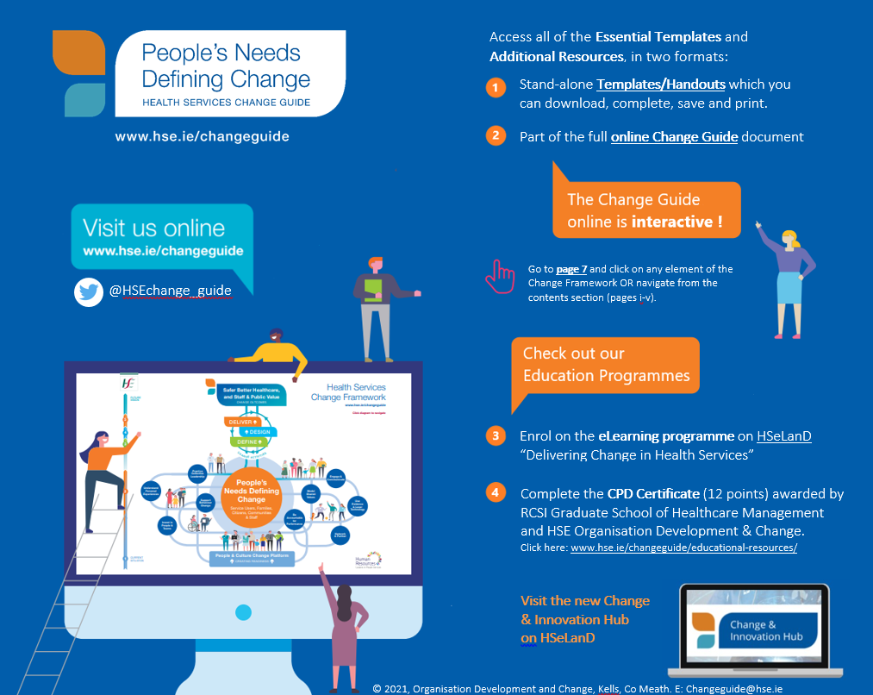

Further information  Email: changeguide@hse.ie  Change & Innovation Hub: www.hseland.ie  Twitter: @HSEchange_guide  www.hse.ie/changeguide | Developed by: Organisation Development & Change, HSE Change & Innovation, Healthcare Strategy, Kells, Co. Meath, A82 H3C7.  © Health Service Executive 2022

